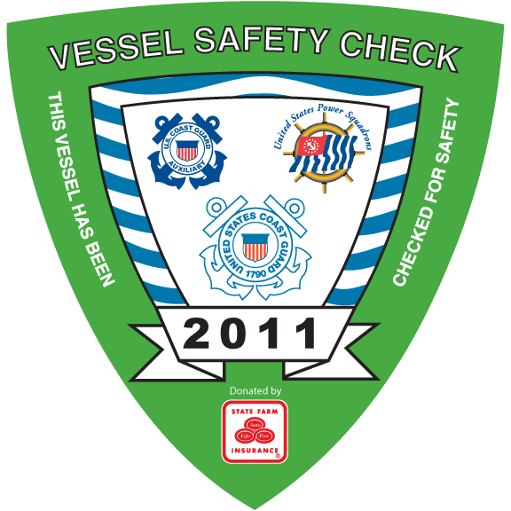
U.S. Coast Guard Auxiliary
Vessel Safety Check Day
During:

at:
Kings Island
September 3rd 2011
from
8:00 A.M to 1:00 P.M.
Here’s an opportunity to have the safety equipment on your vessel examined by a qualified examiner of the Coast Guard Auxiliary, the SAME exam you may encounter if boarded by the Coast Guard or the Sheriff while on the water. However, there are NO fines, penalities or reports to any agency. If your vessel is properly equiped, you’ll be presented with the current 2011 VSC decal. Display of the decal does NOT guarantee that you will not be boarded. But, should you be boarded or need the equipment, you’ll have peace of mind in knowing you will have the correct equipment and where it is located.

The 15 minute Vessel Safety Check includes a check of:
Numbering, registration or documentation, lifejackets, visual distress, fire extinguishers, ventilation, backfire flame arrester, horn, navigation lights, pollution and trash placards, the marine sanitation device and many other important requirements.
If you have ANY questions regarding the exam or equipment requirements, please contact:
Mike Lauro
U. S. Coast Guard Auxiliary
at (209)334-2006 or at sumfun@juno.com

