2011 Delta Blitz at Buckley Cove Marina, CA

The total of 184 VSCs makes the Blitz on June 18, and 19 2011, the MOST
productive in the 3 years of the program! This is a solid 15% increase
over last years total of 160 VSCs! Further, with West Marine on site
to supply missing items of safety equipment, the pass/fail ratio
increased from 63% to 81%! West Marine reported over $320 in sales
for both days, and they sold out of type IV PFDs (12 total for the
weekend) on Sunday! The only boaters we were not able to help were
the ones missing their registration documents.
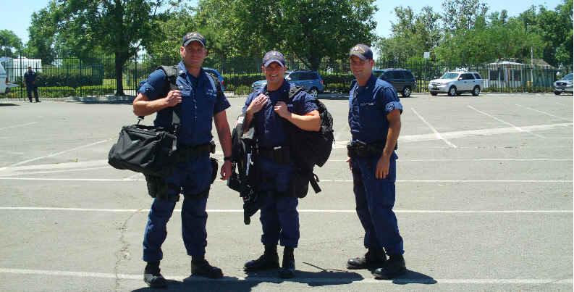

The Coast Guard Ready for the Delta Blitz

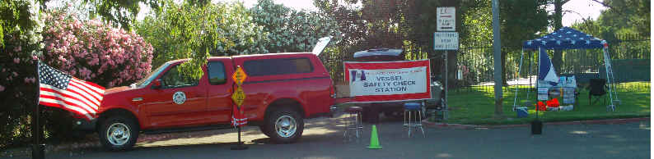

The VSC Mobile Ready for Action
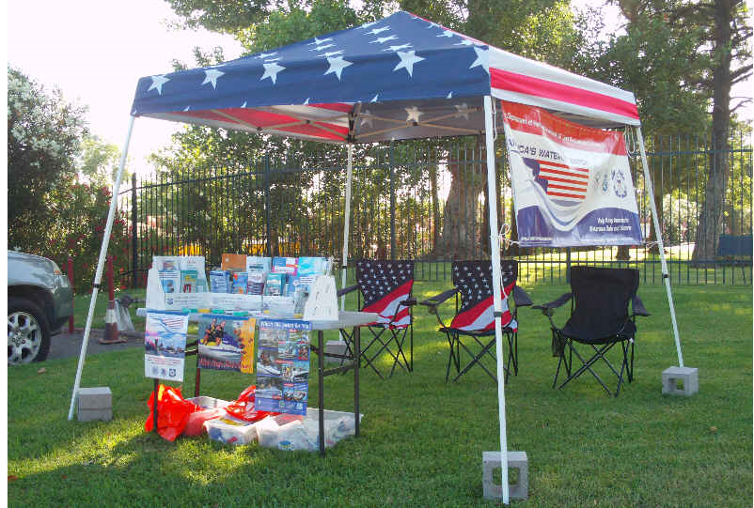
Our Marine Safety Booth provided information for the boating public

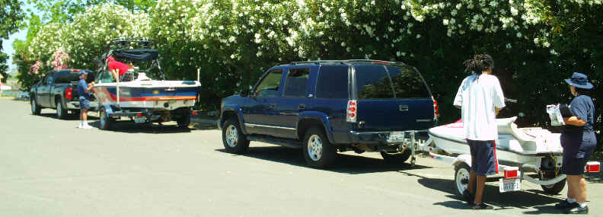
VSCs in progress

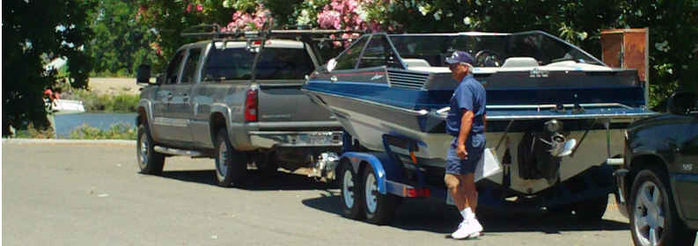
Our illustrious leader, Mike Lauro

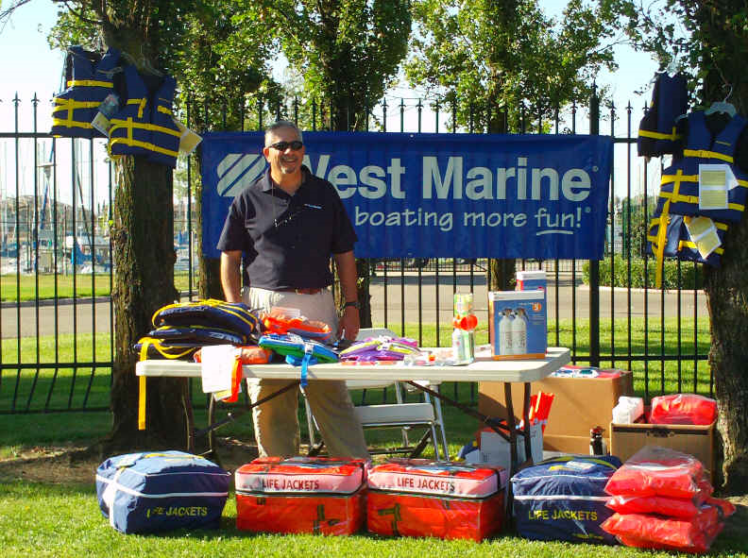
West Marine was on hand to support the Delta Blitz

