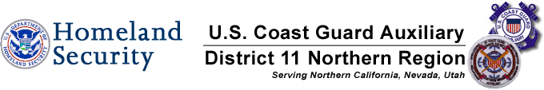

2014 Vessel Safety Check Summary

This is a brief recap of all vessels examined by Mike Lauro DSO-VE vs. National recap .The National Stats are from 2003.
825 Lauro Examinations*** 100,650 National Examinations **
558 Passed-76% 75,386 Passed-74.9%
197 Failed- 27% 25,264 Failed- 25.1%

Breakdown of Vessels Examined by Mike Lauro*

Total VSC’s Performed PCT of Total VSC’s Performed
135 PWC’s 16%
72 Vessels 40 to 65 ft in length 9%
102 Vessels 26 to 39 ft in length 14%
309 Vessels 16 to 25 ft in length 37%
207 Vessels less than 16 ft ex PWC’s inc. Paddlecraft 25%
825 Total Vessels
The following is a recap of the 197 failures, reasons, numbers, and percentages vs. National percentages. The percentages of failures will NOT add up to 100% as many vessels had multiple reasons for failing.
Reason: # Failures % of Failures National Stats**
1-Display of numbers 16 6% 5%
2-Registration 12 5% 5%
3-Personal Flotation Devices 35 22% 3%
4-Visual Distress Signals 13 9% 12%
5-Fire Extinguishers- 16 5% 4%
6-Ventilation- 3 2% 1%
7-Backfire Flame Control 2 1% 2%
8- Sound Producing Devices 55 26% 5%
9-Navigation Lights 26 11% 8%
10-Pollution Placard 5 3% 2%
11-MARPOL Placard 8 3% 3%
12-Marine Sanitation Device 0 0% 3%
13-Navigation Rules 1 1% 3%
14-State Requirements 2 2% 10%
15 Overall Vessel Condition 3 2% 4%

Owner or operator taken a Boating Safety Class? YES 89-13% NO 612- 87%
Unfortunately not everyone was asked or didn’t know.

*These vessels were examined at Inland Waters that includes the Delta. Unfortunately very few vessels were examined in COASTAL WATERS.

**National stats from 2003 are not broken down by pass or failure numbers, length, or area.
***This reflects paddlecraft which has a higher pass rate.

Michael J. Lauro DSO-VE

Rev. 12/14 MJL

