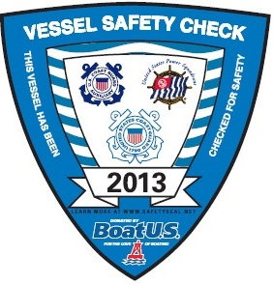

U.S. Coast Guard Auxiliary
Vessel Safety Check

Here’s an opportunity to have your vessel’s safety equipment examined by a qualified examiner of the Coast Guard Auxiliary. There are NO fines, penalities or reports to any agency. If your vessel is properly equipped, you’ll be presented with the current 2013 VSC decal. Display of the decal does NOT guarantee that you will not be boarded. But, should you be boarded or need the equipment, you’ll have peace of mind in knowing you will have the correct equipment and where it is located.
The 15 minute Vessel Safety Check includes a check of:
Numbering, registration or documentation, lifejackets, visual distress, fire extinguishers, ventilation, backfire flame arrester, horn, navigation lights, pollution and trash placards, the marine sanitation device and many other important requirements.
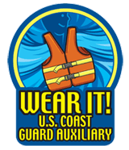
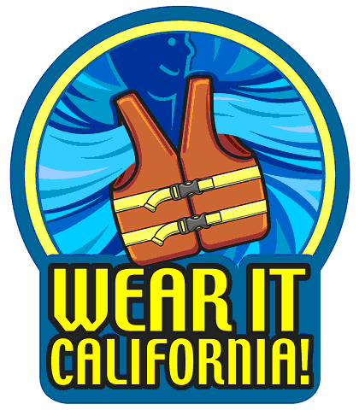
If you have ANY questions regarding the exam or equipment requirements, please contact:

YOUR NAME
U. S. Coast Guard Auxiliary
at (123) 456-7890 or at: your email@email.com

