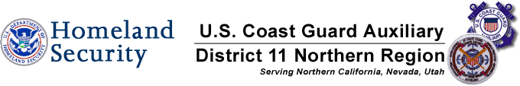

2012 Vessel Safety Check Summary

This is a brief recap of all vessels examined by Mike Lauro DSO-VE vs. National recap .The National Stats are from 2003.

1,051 Lauro Examinations 100,650 National Examinations *
661 Passed-63% 75,386 Passed-74.9%
390 Failed- 37% 25,264 Failed- 25.1%

Breakdown of Vessels Examined by Mike Lauro*

Total VSC’s Performed PCT of Total VSC’s Performed
176 PWC’s 16%
118 Vessels 40 to 65 ft in length 11%
241 Vessels 26 to 39 ft in length 22%
432 Vessels 16 to 25 ft in length 40%
100 Vessels less than 16 ft ex PWC’s inc. Paddlecraft 9%
1067 Total Vessels

The following is a recap of the 395 failures, reasons, numbers, and percentages vs. National percentages. The percentages of failures will NOT add up to 100% as many vessels had multiple reasons for failing.
Reason: # Failures % of Failures National Stats**
1-Display of numbers 48 12% 5%
2-Registration 36 9% 5%
3-Personal Flotation Devices 79 20% 3%
4-Visual Distress Signals 47 12% 12%
5-Fire Extinguishers- 22 5% 4%
6-Ventilation- 3 1% 1%
7-Backfire Flame Control 4 1% 2%
8- Sound Producing Devices 176 44% 5%
9-Navigation Lights 58 14% 8%
10-Pollution Placard 22 5% 2%
11-MARPOL Placard 18 4% 3%
12-Marine Sanitation Device 1 0% 3%
13-Navigation Rules 10 2% 3%
14-State Requirements 10 2% 10%
15 Overall Vessel Condition 27 7% 4%

*These vessels were examined at Lake Camanche and throughout the Delta. Unfortunately very few vessels were examined in COASTAL WATERS.

**National stats from 2003 are not broken down by pass or failure numbers, length, or area.

Michael J. Lauro DSO-VE

Rev. 12/12 MJL/sl

